Take the company name and search in SF and select the licenses which they have in contract.

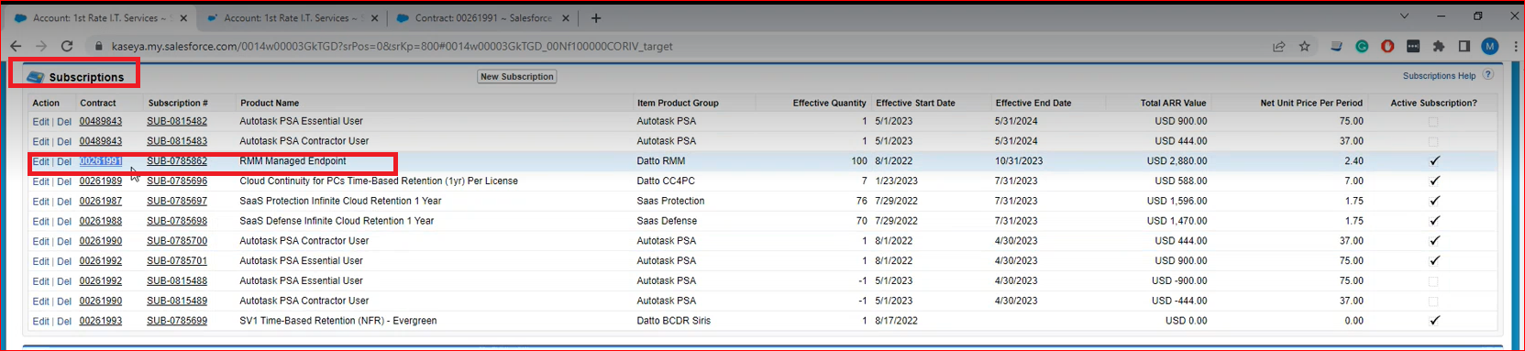

Click on Initiate Contract modification

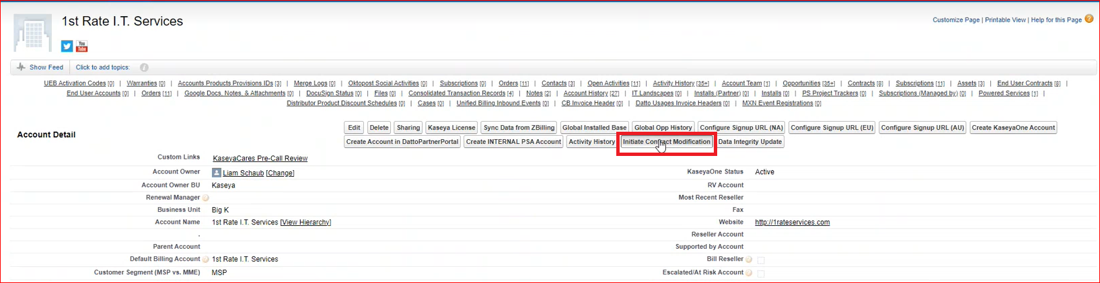

Update the date/bill to contact/Primary contact/Ship to contact and select the contract which has to be debooked and click on next

FYI: start date will be if you are starting before 15 then it will be 1st of this month or its after 15th of this month then you will set as 1st of next month.

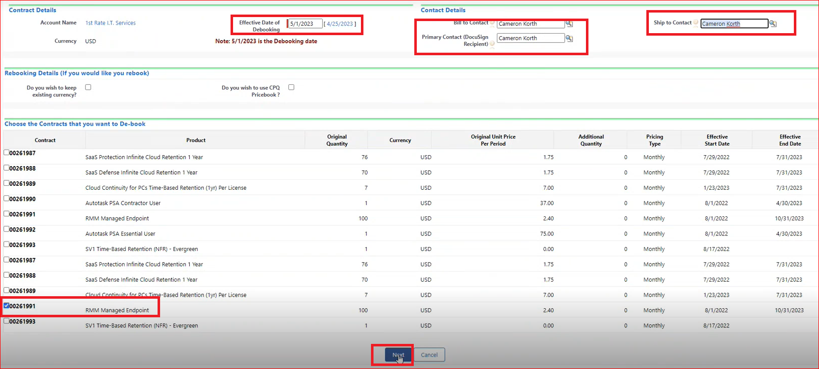

This is Rebooking transaction. Tick on other and update the end date and generate the transaction

wait till it completes creating the opportunity and quote.

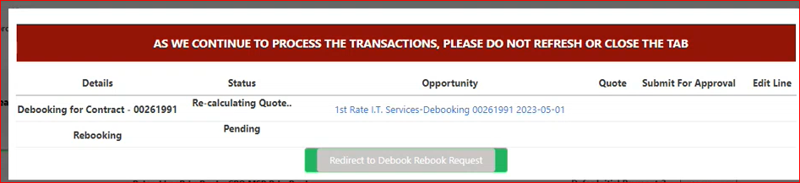

Its created DE booking/opportunity/Quote Rebooking opportunity/Quote, (open both opportunity/quote & click to redirect to de-book re-book request.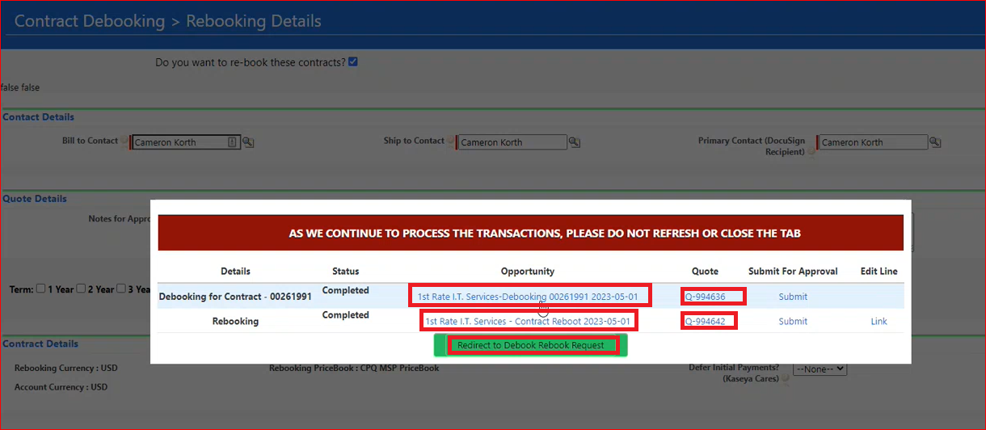

Open opportunity and quote and click on re-direct on rebook/debook request

In the Debook opportunity you will have find 1 Debooking and 1 rebooking

Check the dates

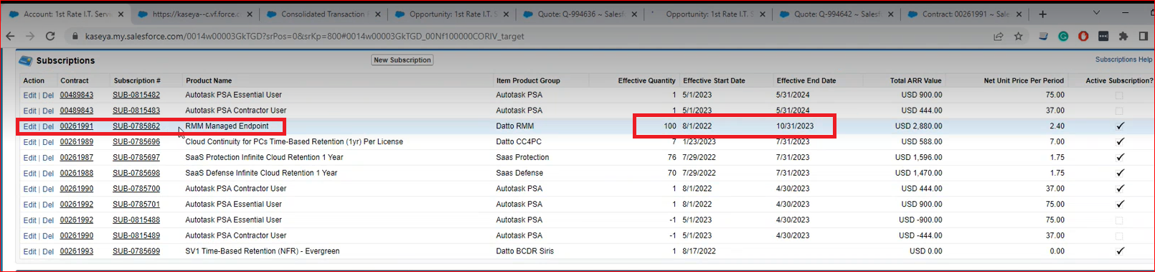

Open the De-booking quote and click on edit lines

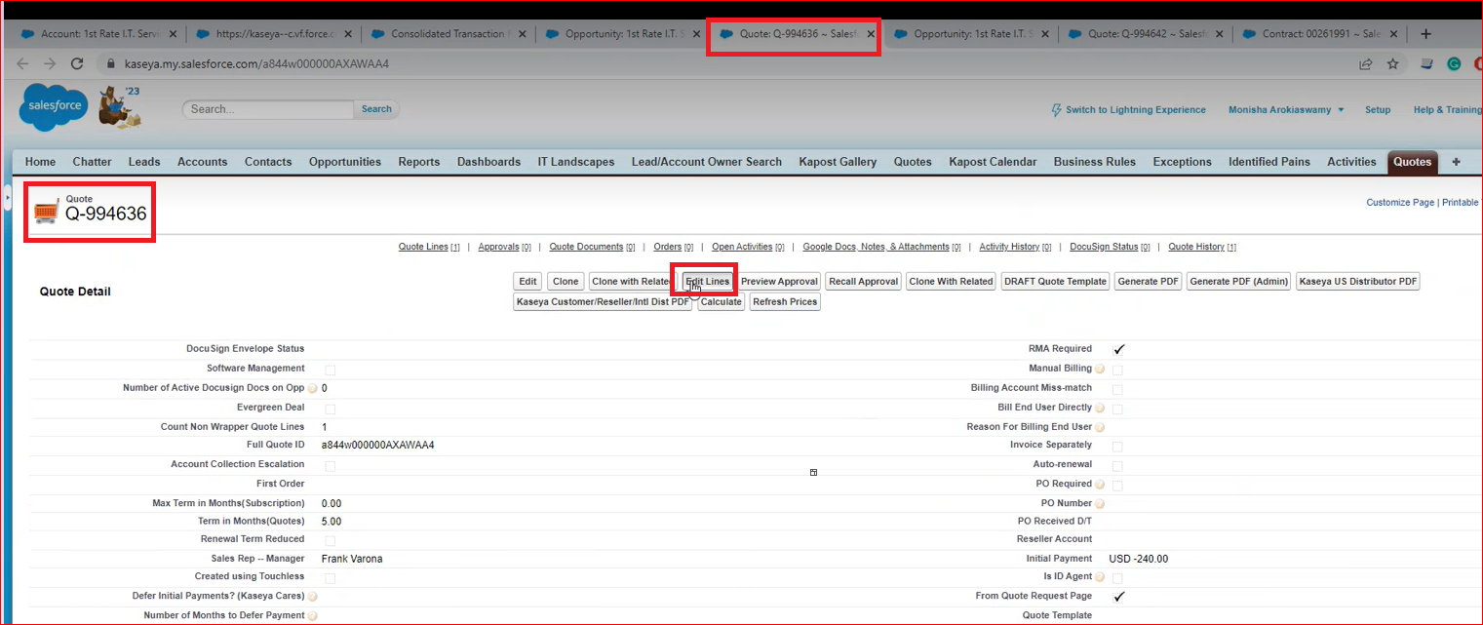

Tick the over-ride and click save

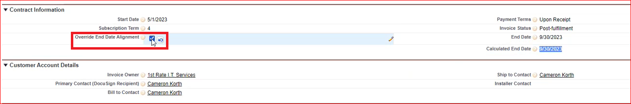

Again click on edit lines update the correct end date as on SF, check the pricing and click on calculate and save.

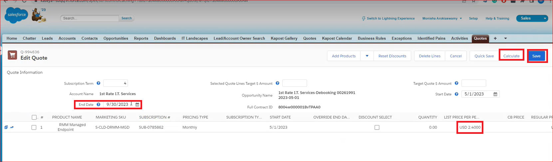

Generate PDF

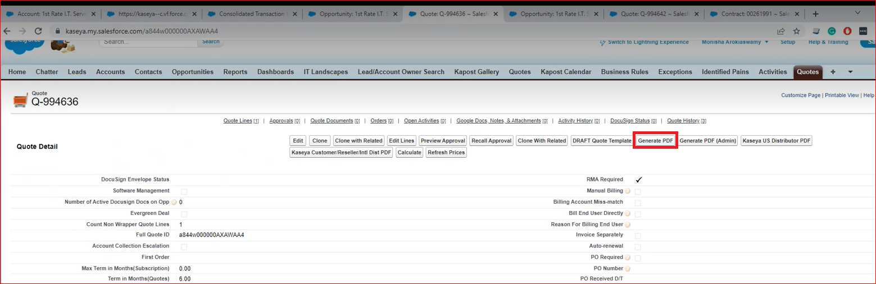

Click on download and PDF will get download

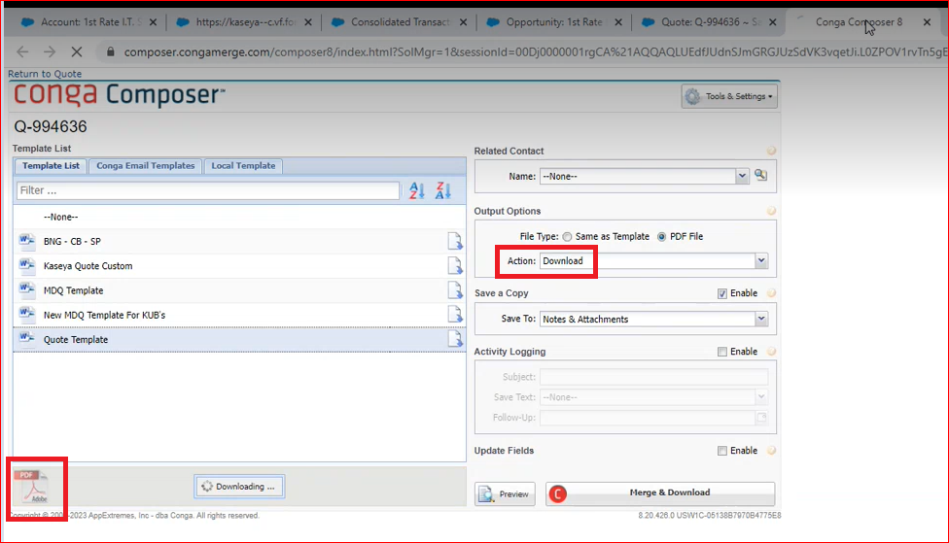

Check if everything is matching as per the contract on SF.

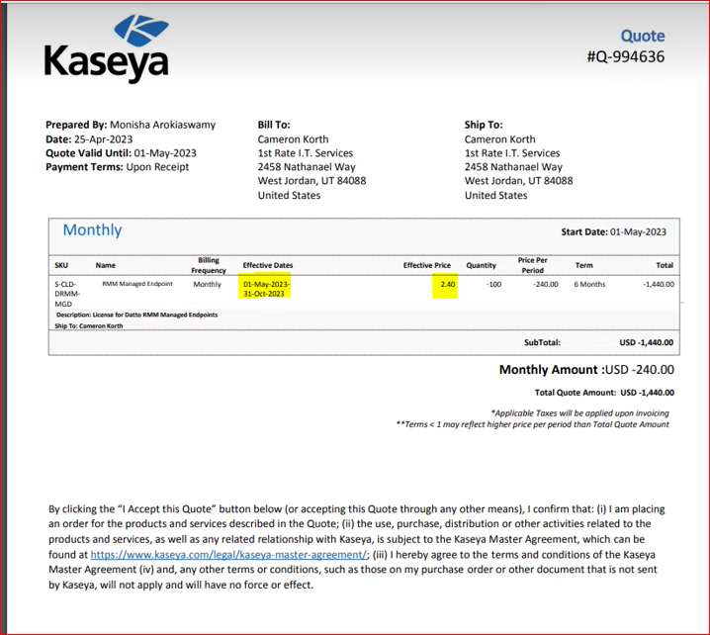

Now open the re-booking quote click on generate PDF and cross check the price and dates matches.

Next open the consolidation and update the notes

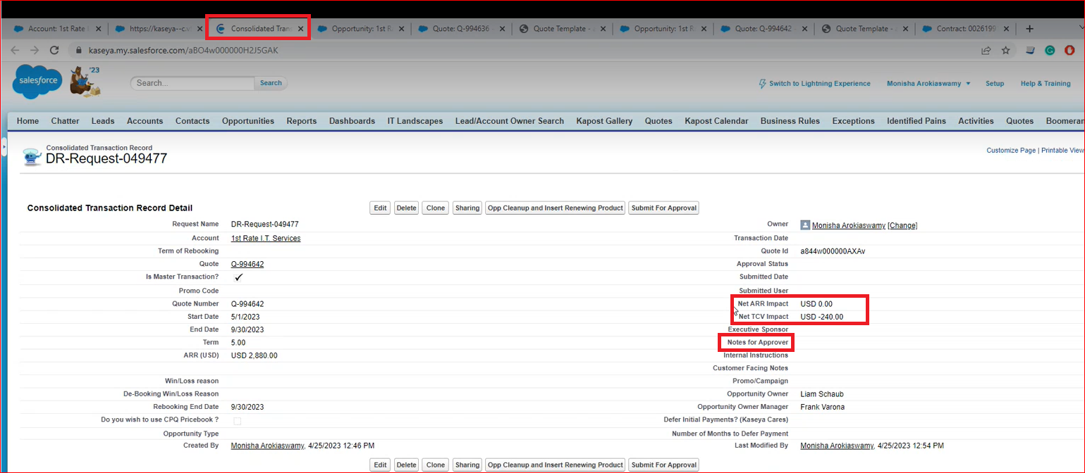

Update the notes and copy it and updated in Notes for Approver

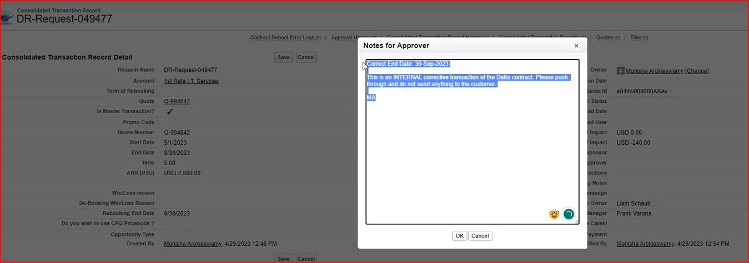

and updated the same in internal instruction and save

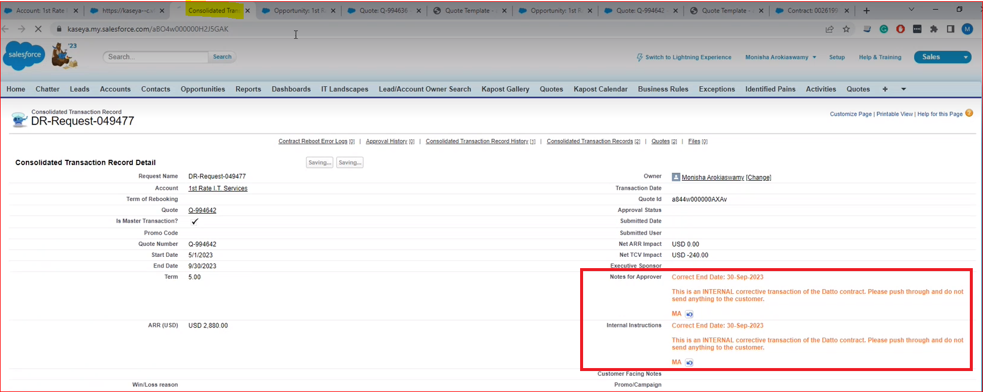

Now open the Debooking opportunity in that sub heading Additional instruction/ Description field paste the notes

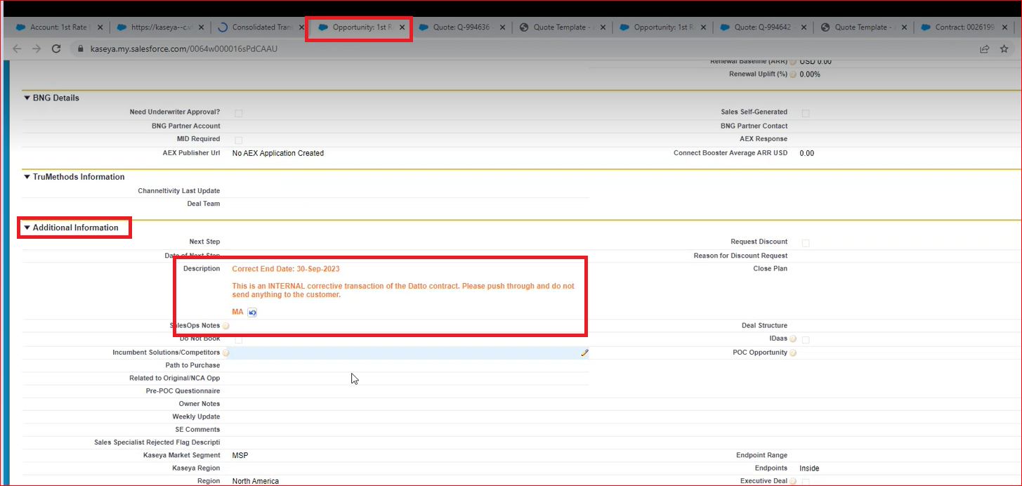

In the win loss details: update the comments in win loss notes and click save

In the opportunity/ Primary product interest update the licenses they have taken and save

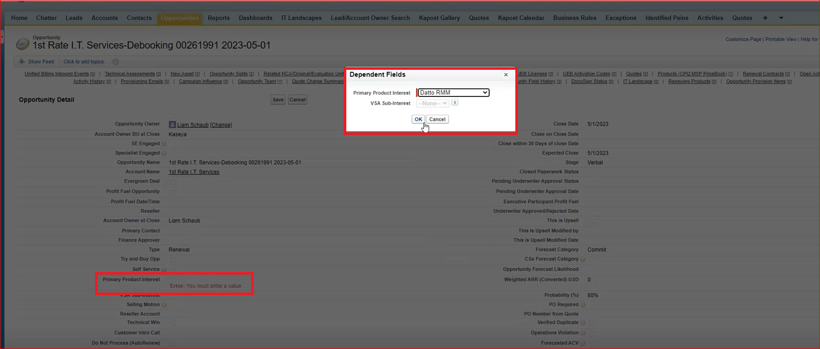

Go to the quote and update the notes and save

Go to the Rebooking opportunity and update the notes

Go to win Loss Details and update the notes and save

Go to the re-book Opportunity and update the renewal baseline amount and save.  
  
NOTE: Renewal Baseline is the ARR of the Debooking quote.

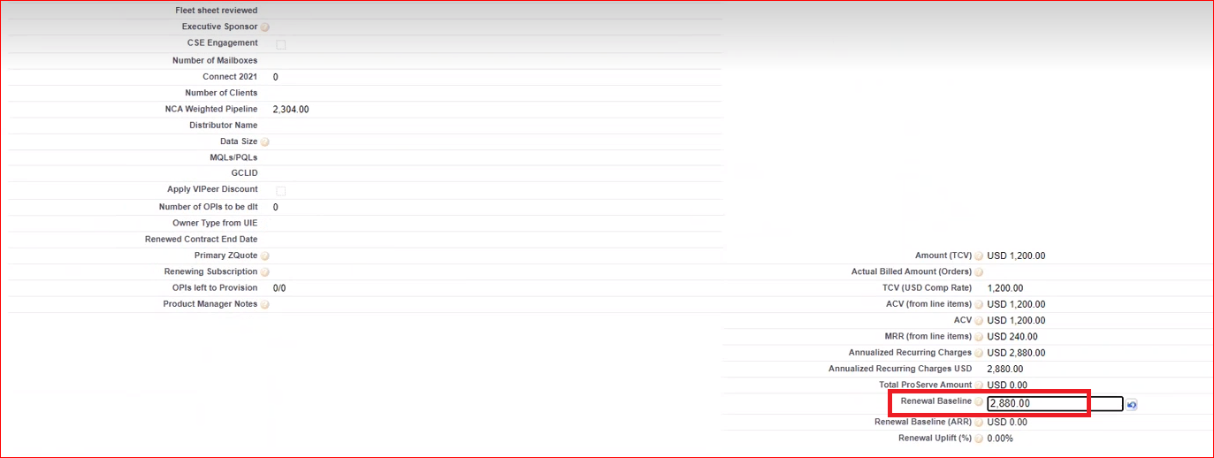

Contact conversion will be NO and save

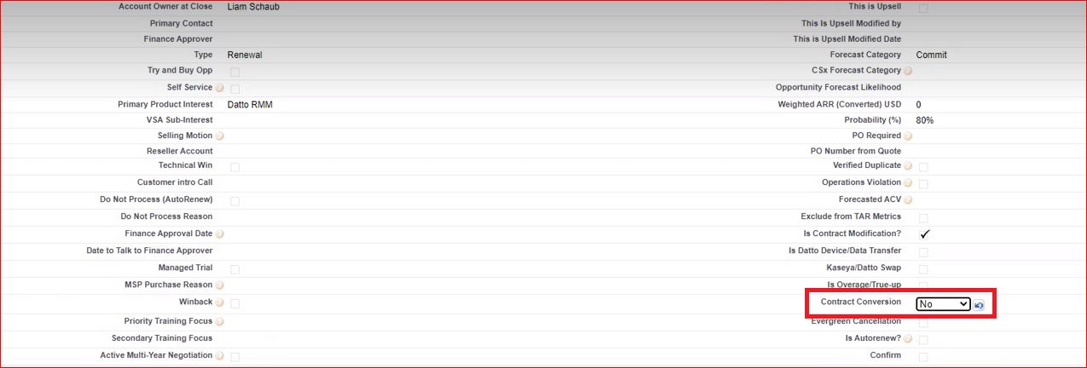

Debooking Opp  
  
Opp Type: Renewal

Opp Owner: Account Owner

Close Date: ‘Today’

Contract Conversion: NO

Exclude From TAR Metrics: True

Is Contract Modification?: True

*Debooking Win/Loss Reason: Contract Reboot*

Rebooking Opp

Opp Type: Renewal

Opp Owner: Account Owner

Close Date: ‘Today’

Contract Conversion: NO

Exclude From TAR Metrics: False

Is Contract Modification?: True

Skip Auto-Provisioning: True

*MUST include BASELINE ARR*